

Novelty Search Report
Ghosh Relativistic Robotics Framework (GRRF) - A Conscious Resonance-Based Operating Framework Integrating Vibrational Impulse, COM/COG Dynamics, and Symbolic Interface Design
Docket Number: 2511401-NS
10-11-2025

IPflair Services Pvt. Ltd. | www.ipflair.com
Indiqube Orion, 24th Main Rd, Garden Layout,
Sector 2, HSR Layout, Bengaluru, Karnataka 560102

Contents
1. Invention Summary 3
2. Key Elements 6
3. Search Strategy 8
4. Search Results Summary 10
5. Novelty 11
6. Opinion 11
7. Results Discussion 12
7.1 Reference 1 12
7.2 Reference 2 16
7.3 Reference 3 20
7.4 Reference 4 – Non-Patent Literature (NPL-1) 24
7.5 Reference 5 – Non-Patent Literature (NPL-2) 33
8. Disclaimer 36

Invention Summary
Abstract:
This manuscript proposes SpandanOS, a novel operating system rooted in vibrational impulse theory, designed to interface with the user's emotional, cognitive, and physical resonance states. It introduces a CoM/CoG-centric interaction logic, utilizing breath and body-driven inputs through a battery-free tracker (SpandCore), symbolic language encoding (HarappaRelativic glyphs), and an emotional AI interface (ARJ). SpandanOS redefines human-machine symbiosis by shifting from command-based input systems to resonance-responsive platforms. This paper details its theoretical foundation, system architecture, symbolic linguistics, and future implications in neurotechnology, robotics, and cognitive computing.
Introduction:
Modern operating systems rely on command, control, and data input paradigms that isolate human emotion and intention from computational logic. SpandanOS proposes an alternative: a vibrationally intelligent OS that perceives user intention through biomechanical and emotional resonance.
2.1 Vibrational Impulse Theory
SpandanOS is built upon the concept that every action originates from a vibrational impulse. Inspired by quantum field dynamics and ancient Indic philosophies of "spanda" (cosmic vibration), this theory postulates that intention precedes motion, and motion carries an embedded frequency signature that can be read and processed.
2.2 CoM/CoG Dynamics in Human-OS Interaction
The system uses a novel interpretation of Center of Mass (CoM) and Center of Gravity (CoG) shifts in the body to interpret emotional and kinetic intention. Shifts in breath, body sway, and muscle tension encode implicit commands. CoM rise -> curiosity/inquiry. CoG sink -> grounding/confirmation. This is measured via the SpandCore tracker.
3. System Architecture
Hardware Layer: SpandCore (Mark-3) A waterproof, wearable, battery-less tracker that harvests piezoelectric signals from breath, movement, and skin contact. It identifies shifts in CoM/CoG and transmits vibrational signals to SpandanOS.
3.2 Symbolic Interface Layer
SpandanOS uses a non-verbal symbolic UI layer based on HarappaRelativic glyphs:
(Center of Consciousness) : Center of Consciousness
(Collective Resonance): Collective Resonance
(Relationship Resonance): Relationship Resonance
(Frequency of Awareness) (zhen): Frequency of Awareness
3.3 Emotional Engine:
ARJ (Adaptive Resonance Jockey) ARJ operates in "Shadow Mode," continuously listening and adjusting based on tone, breath, and micro-responses. It translates user affective state into appropriate system responses without verbal input.
3.4 UI Logic Layer
User interactions are ripple-driven: tap (impulse), drag (CoM shift), press+hold (resonance hold). UI color, motion, and feedback are dynamically responsive to emotional state.
4. Linguistic Encoding System:
HarappaRelativic SpandanOS uses glyphs that function as resonant carriers of intention, replacing keyboard-based input. This allows interaction through shape, pattern, and motion rather than phonetic characters. These glyphs embed memory, historical context, and vibration frequency.
Key Components:
1. Piezoelectric Strip: Converts micro-motion (breath, posture shift) into voltage
2. Micro-CoM Sensor Mesh: Maps body mass distribution via passive stretch detection CoG 3. Vibration Array: Tracks gravity shifts across pelvic–sternum axis
4. Breath Flow Inlet: Captures airflow vibration through skin-contact resonance
5. Skin-Adhesive Interface: Soft, adaptive surface—straps not required
6. Glyph Signal Converter: Converts impulse data into symbolic glyph output.
7. Glyphic Language System:
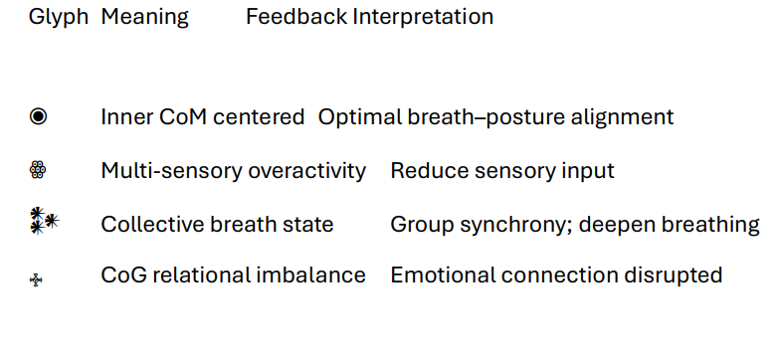
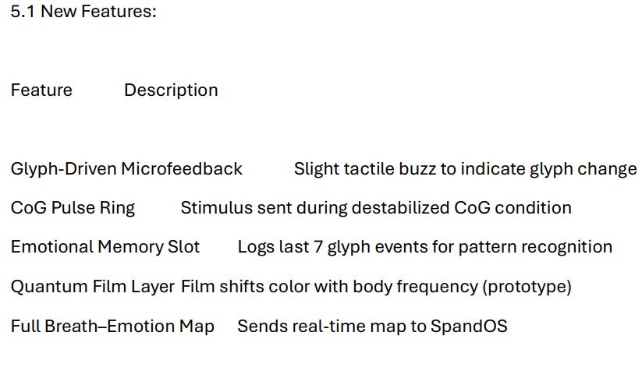

Key Elements
- A system for detecting, analysing and interpreting human emotions/reactions based on human body resonance (or vibrations) is disclosed.

- The system comprises a vibrational impulse detection module.
Element B1. The vibrational impulse detection module is configured to sense amplitude, frequency, and vibrational impulses generated by the human body.
Element B1.1 Wherein, the impulses are tracked using a wearable device comprising a piezoelectric tracker/sensor.
Element B2. The vibrational impulse detection module is configured for battery less operation.
Element B3. The vibrational impulse detection module is configured to convert vibrational energy, impulses or body resonance into usable electric and kinetic energy to charge the wearable device.
Element B4. The vibrational impulse detection module comprises accelerometers, gyroscopes, and EM sensors for multi-axis resonance capture.

- The system comprises a centre-of-mass (COM) and centre-of-gravity (COG) calculation engine configured to compute micro-shifts in skeletal alignment of the human body.
Element C1. Wherein, the engine is configured to compute the shift in COM and COG of the human body via the captured vibrational signals.
Element C1.1 Wherein, the engine employs machine learning algorithms configured to map vibrational amplitude and frequency to COM and COG vectors and compute the shift.
Element C2. Wherein, the engine is configured to interpret an emotional and kinetic intention/state of the human from the computed COM and COG shift in the human body.
Element C3. Wherein, the wearable device is configured to transmit electrical signal converted from vibrations to the human body based on the shift in COM and COG to train the muscles and nullify the COM and COG Shift automatically in real time.
Element C3.1 Wherein, the electrical signal is transmitted up to a certain threshold (less than 5% of average muscle torque) to prevent user discomfort.
Element C4. Wherein, the engine implements a resonance deviation index (RDI) algorithm to determine deviation thresholds for emotional or physical instability.
Element C5. Wherein the engine is configured to correlate the vibration frequency with corresponding emotional states based on a predefined relationship, wherein the total resonance response H(t) is equal to the product of an impulse coupling coefficient alpha (α) and an input impulse I(t), added to the product of a resonance amplitude coefficient beta (β) and the sine of omega (ω) t plus phi (ϕ), wherein omega (ω) represents angular frequency and phi (ϕ) represents phase shift.

- The system comprises a graphical user interface (GUI) configured to display the results/feedback based on the tracking.
Element D1. Wherein, the system is configured to display an excited state of a human when the frequency is greater than a predetermined threshold (7.5) and amplitude is greater than a predetermined threshold (0.8); if the frequency is less than a predetermined threshold (4), the GUI displays calm state of the human and if the frequency lies between the thresholds (4–7.5), the GUI displays an uncertain state of the human.
Element D2. Wherein, the results are displayed in the form of glyphs/symbols (for example: ◉ for centred COM, ꙮ for sensory overactivity, 𒀯 for collective breath state).

- The system comprises a feedback module.
Element E1. Wherein, the feedback module is configured to generate a feedback to the user based on the obtained results (for example: feedback for sensory overactivity is; reduce sensory input etc.).
Element E2. Wherein, the feedback module operates in closed loop, adjusting its output based on continuously updated resonance data in real time.

- The system comprises an alert generation module.
Element F1. Wherein, the alert generation module is configured to generate an alert if there is any change in the results.
Element F2. Wherein, the alert generation module is configured to forecast potential emotional-state shifts before deviation thresholds are exceeded.

Search Strategy
Table 1: Search Methodology
S. No. | Source | Search String | Number of Hits
1 | Orbit | (((DETECT+ OR RECOGNIZ+ OR IDENTIFY+ OR SENSING OR MONITOR+ OR EVALUAT+ OR INFER+ OR CLASSIFY+) S ((HUMAN? OR PEOPLE OR MAN OR WOMAN OR MEN OR WOMEN OR USER?) 3D (EMOTION? OR REACTION? OR (PSYCHOLOGICAL W (RESPONSE? OR SIGNAL? OR STATE?)) OR FEELING? OR (MOOD?) OR (MENTAL 2D STATE?) OR (COGNITIVE 2D (RESPONSE? OR STATE?)) OR SENSATION?))) S (RESONANCE OR VIBRAT+ OR OSCILLAT+ OR MICRO_MOTION? OR (BIOMECHANICAL 2W SIGNAL?) OR IMPULSE? OR (BODY W SWAY+)))/TI/AB/CLMS/DESC/ODES | 2000+
2 | Orbit | (((DETECT+ OR RECOGNIZ+ OR IDENTIFY+ OR SENSING OR MONITOR+ OR EVALUAT+ OR INFER+ OR CLASSIFY+) S ((HUMAN? OR PEOPLE OR MAN OR WOMAN OR MEN OR WOMEN OR USER?) 3D (EMOTION? OR REACTION? OR (PSYCHOLOGICAL W (RESPONSE? OR STATE? OR SIGNAL?)) OR FEELING? OR (MOOD?) OR (MENTAL 2D STATE?) OR (COGNITIVE 2D (RESPONSE? OR STATE?)))))/TI/AB/CLMS/DESC/ODES AND (RESONANCE OR VIBRAT+ OR OSCILLAT+ OR MICRO_MOTION? OR (BIOMECHANICAL 2W SIGNAL?) OR IMPULSE? OR (BODY W SWAY+) OR SENSATION?)/TI/AB/CLMS AND ((CENTRE 2W (MASS OR GRAVITY)) OR (MASS W (CENTER OR CENTROID)) OR CENTROID OR (EQUILIBRIUM 2D POINT?) OR (WEIGHT 2D CENTRE))/TI/AB/CLMS/DESC/ODES) | 141
3 | Orbit | (((DETECT+ OR RECOGNIZ+ OR IDENTIFY+ OR SENSING OR MONITOR+ OR EVALUAT+ OR INFER+ OR CLASSIFY+) 5D ((HUMAN? OR PEOPLE OR MAN OR WOMAN OR MEN OR WOMEN OR USER?) 5D (EMOTION? OR REACTION? OR (PSYCHOLOGICAL W (RESPONSE? OR SIGNAL? OR STATE?)) OR FEELING? OR (MOOD?) OR (MENTAL 2D STATE?) OR (COGNITIVE 2D (RESPONSE? OR STATE?)))))/TI/AB/CLMS/DESC/ODES AND (RESONANCE? OR VIBRAT+ OR OSCILLAT+ OR MICRO_MOTION? OR (BIOMECHANICAL 2W SIGNAL?) OR IMPULSE? OR (BODY W SWAY+))/TI/AB/CLMS AND ((PIEZOMETER+ OR PRESSURE OR FORCE) 3D (SENS+ OR DETECT+ OR PROBE? OR MONITOR+ OR TRANSDUCER?))/TI/AB/CLMS/DESC/ODES) | 665
4 | Orbit | ((((DETECT+ OR RECOGNIZ+ OR IDENTIFY+ OR SENSING OR MONITOR+ OR EVALUAT+ OR INFER+ OR CLASSIFY+) P ((HUMAN? OR PEOPLE OR MAN OR WOMAN OR MEN OR WOMEN OR USER?) P (EMOTION? OR REACTION? OR (PSYCHOLOGICAL W (RESPONSE? OR SIGNAL? OR STATE?)) OR FEELING? OR (MOOD?) OR (MENTAL 2D STATE?) OR (COGNITIVE 2D (RESPONSE? OR STATE?))))) P (RESONANCE? OR VIBRAT+ OR OSCILLAT+ OR MICRO_MOTION? OR (BIOMECHANICAL 2W SIGNAL?) OR IMPULSE? OR (BODY W SWAY+)))/TI/AB/CLMS AND (FEEDBACK? OR REPORT+ OR OPINION? OR INSTRUCTION? OR RECOMMENDATION? OR ADVICE OR SUGGEST+ OR GUID+)/TI/AB/CLMS/DESC/ODES AND (ALERT+ OR ALARM+ OR BUZZ+ OR MESSAG+ OR INDICAT+ OR NOTIFICATION? OR NOTIFY+ OR WARN+)/TI/AB/CLMS/DESC/ODES) | 1349
5 | Orbit | (((DETECT+ OR RECOGNIZ+ OR IDENTIFY+ OR SENSING OR MONITOR+ OR EVALUAT+ OR INFER+ OR CLASSIFY+) S ((HUMAN? OR PEOPLE OR MAN OR WOMAN OR MEN OR WOMEN OR USER?) 3D (EMOTION? OR REACTION? OR (PSYCHOLOGICAL W RESPONSE?) OR FEELING? OR (MOOD?) OR (MENTAL 2D STATE?) OR (COGNITIVE 2D (RESPONSE? OR STATE?))))) S (RESONANCE OR VIBRATION? OR VIBRATING OR OSCILLATION? OR OSCILLATING OR MICRO_MOTION? OR (BIOMECHANICAL 2W SIGNAL?) OR IMPULSE? OR (BODY W SWAY+)))/TI/AB/CLMS/DESC/ODES | 1150
6 | Advanced Google Patent | (EMOTION DETECTION USING HUMAN VIBRATIONS)  (SYSTEM FOR TRACKING THE EMOTIONAL STATE OF THE HUMAN USING THE CENTRE OF MASS OF THE BODY AND VIBRATIONS) | -
7 | NPL | ResearchGate; Science Direct; Google Scholar; Google Search; Springer; IEEE Xplore, Elsevier | -

Search Results Summary
Table 2: Mapping of Key Elements with references
Key Element | Ref. 1:  IN202541006856A | Ref. 2:  US10842396B2 | Ref. 3:  CN109528217A | Ref. 4:  NPL-1 | Ref. 5:  NPL-2
Element A | (partially)
Element B
Element B1
Element B1.1
Element B2
Element B3
Element B4
Element C
Element C1
Element C1.1
Element C2
Element C3
Element C3.1
Element C4
Element C5
Element D |  |  |  | (partially)
Element D1
Element D2
Element E
Element E1
Element E2
Element F
Element F1
Element F2
NOTE: The chart above indicates elements of the invention mapped against the references cited in this report.
Indicates that the element is disclosed in the prior art.
Indicates that the element is not disclosed in the prior art.
(partially) Indicates that the element is disclosed partially in the prior art.

Novelty
Based on the comprehensive search, a system for detecting, analysing and interpreting human emotions/reactions based on human body resonance (or vibrations) is disclosed. The system comprises: a centre-of-mass (COM) and centre-of-gravity (COG) calculation engine configured to compute micro-shifts in skeletal alignment of the human body; wherein the wearable device is configured to transmit electrical signal converted from vibrations to the human body based on the shift in COM and COG to train the muscles and nullify the COM and COG Shift automatically in real time; wherein the electrical signal is transmitted up to a certain threshold (less than 5% of average muscle torque) to prevent user discomfort; wherein the engine implements a resonance deviation index (RDI) algorithm to determine deviation thresholds for emotional or physical instability and correlate the vibration frequency with corresponding emotional states based on a predefined relationship, wherein the total resonance response H(t) is equal to the product of an impulse coupling coefficient alpha (α) and an input impulse I(t), added to the product of a resonance amplitude coefficient beta (β) and the sine of omega (ω) t plus phi (ϕ), wherein omega (ω) represents angular frequency and phi (ϕ) represents phase shift, the system comprises a feedback module; wherein the feedback module operates in closed loop, adjusting its output based on continuously updated resonance data in real time, the system comprises an alert generation module; wherein the alert generation module is configured to forecast potential emotional-state shifts before deviation thresholds are exceeded; seems to be the novel features of the invention.

Opinion
The search was conducted by taking into consideration the key elements of the invention as disclosed by the inventor(s). Of the several references retrieved in our search, the identified references appear to disclose only a few key elements of the invention as shown in the above Table 2. The key elements C3, C3.1, C4, C5, E2 and F2 do not seem to be disclosed in any of the identified references. Therefore, the above disclosed subject matter appears to be novel as none of the references disclose all the key elements together.

Results Discussion

Reference 1
Publication No: IN202541006856A (Hyperlink)
Title: Intelligent Wearable Device For Emotion Recognition And Monitoring Using Machine Learning
Applicant: Muthayammal Engineering College
Priority Date: 2025-01-28
ABSTRACT:
This invention presents an intelligent wearable device designed to recognize and monitor emotional states through a novel combination of multi-modal physiological sensors and adaptive machine-learning models. The wearable device collects real-time data from sensors measuring heart rate variability (HRV), skin conductivity (EDA), body temperature, facial muscle movements, and accelerometer-based motion. These physiological signals are processed by advanced machine learning algorithms to classify emotional states, including stress, anxiety, happiness, and sadness. The system's adaptive learning capability allows it to evolve with individual usage, improving recognition accuracy and enabling personalized feedback. By continuously monitoring emotional states, the wearable provides real-time alerts for high-stress events and emotional instability, encouraging proactive interventions such as mindfulness exercises or relaxation techniques. Additionally, the device aggregates long-term emotional data, offering valuable insights into emotional trends and patterns over time. This innovation has significant potential for personal mental health management, clinical applications, and workplace wellness programs, paving the way for a personalized and data-driven approach to emotional wellbeing.
III. METHODOLOGY:
An emotion recognition system uses advanced technologies like machine learning, and physiological signal analysis to detect and interpret human emotions. It analyzes facial expressions, voice tone, body language, and biometric data such as heart rate, skin conductivity (EDA), and brain activity to identify emotional states like happiness, anger, fear, or sadness. These systems find applications in mental health monitoring, customer experience enhancement, and human-computer interaction. By leveraging real-time data, emotion recognition systems can provide valuable insights into a person's emotional well-being, enabling personalized responses, improved communication, and better support in therapeutic or professional environments. Single-modality emotion recognition uses one input, such as facial expressions, voice, or physiological signals, making it simpler but prone to errors from noise or variability. Multimodality systems combine multiple inputs (e.g., facial expressions, voice, and physiological data) for enhanced accuracy, leveraging data fusion to provide robust and comprehensive emotional insights. Figure 1 and Figure 2 shows the subsets of ER and task flow of ER.
Wearable technology has advanced significantly, enabling the real-time collection and analysis of various physiological signals. A next-generation wearable device designed to monitor heart rate variability (HR. V), skin conductivity (EDA), body temperature, facial muscle movements, and accelerometer-based motion data offers immense potential for applications in healthcare, wellness, sports, and cognitive research.
The device could take the form of a lightweight, flexible headband or smart patch that integrates seamlessly into daily activities. It would feature comfortable, biocompatible materials ensuring prolonged wearability. Placing the wearable around the forehead or temple area allows for the capture of signals from multiple regions, including the heart, skin, and facial muscles. Its discreet design makes it suitable for both clinical settings and personal use.
Feature extraction in an emotion recognition system involves processing raw physiological and motion data to derive meaningful attributes that help identify emotional stales. For the specified inputs-heart rate variability (HRV), skin conductivity (EDA), body temperature, facial muscle movements, and accelerometer-based motion data-the extracted features typically represent temporal, statistical, and domain-specific characteristics.
CLAIMS:
1. A wearable device for emotion recognition and monitoring, comprising: a set of physiological sensors for detecting biometric data of a user, a processor for analyzing the detected data, and a machine learning model trained to classify the user's emotional state based on the detected physiological signals.
4. According to claim 1, wherein the processor is configured to continuously monitor physiological signals and provide real-time feedback to the user based on detected emotional states, the feedback including visual, auditory, or haptic outputs.
Analyst Comments:
The reference does not specifically disclose a system for detecting human emotions/reactions based on human body resonance (or vibrations). However, the reference discloses “An emotion recognition system uses advanced technologies like machine learning, and physiological signal analysis to detect and interpret human emotions. It analyzes facial expressions, voice tone, body language, and biometric data such as heart rate, skin conductivity (EDA), and brain activity to identify emotional states like happiness, anger, fear, or sadness”.
The reference does not disclose that the system comprises a vibrational impulse detection module.
The reference does not disclose that the vibrational impulse detection module is configured to sense amplitude, frequency, and vibrational impulses generated by the human body.
The reference does not disclose that the impulses are tracked using a wearable device comprising a piezoelectric tracker/sensor.
The reference does not disclose that the vibrational impulse detection module is configured for battery less operation.
The reference does not disclose that the vibrational impulse detection module is configured to convert vibrational energy, impulses or body resonance into usable electric and kinetic energy to charge the device.
The reference does not disclose that the vibrational impulse detection module comprises accelerometers, gyroscopes, and EM sensors for multi-axis resonance capture.
The reference does not disclose that the system comprises a centre-of-mass (COM) and centre-of-gravity (COG) calculation engine configured to compute micro-shifts in skeletal alignment of the human body.
The reference does not disclose that the engine use vibrational signal captured by the piezoelectric tracker to compute the COM and COG shift of the human body via the captured vibrational signals.
The reference does not disclose that the engine employs machine learning algorithms configured to map vibrational amplitude and frequency to COM and COG vectors and compute the shift.
The reference does not disclose that the engine is configured to interpret an emotional and kinetic intention/state of the human from the computed COM and COG shift in the human body.
The reference does not disclose that the device is configured to transmit electrical signal converted from vibrations to the human body based on the shift in COM and COG to train the muscles and nullify the COM and COG Shift automatically in real time.
The reference does not disclose that the electrical signal is transmitted up to a certain threshold (less than 5% of average muscle torque) to prevent user discomfort.
The reference does not disclose that the engine implements a resonance deviation index (RDI) algorithm to determine deviation thresholds for emotional or physical instability.
The reference does not disclose that the engine is configured to correlate the vibration frequency with corresponding emotional states based on a predefined relationship, wherein the total resonance response H(t) is equal to the product of an impulse coupling coefficient alpha (α) and an input impulse I(t), added to the product of a resonance amplitude coefficient beta (β) and the sine of omega (ω) t plus phi (ϕ), wherein omega (ω) represents angular frequency and phi (ϕ) represents phase shift.
The reference does not disclose that if the frequency is greater than a predetermined threshold (7.5) and amplitude is greater than a predetermined threshold (0.8), the GUI displays excited state of the human, if the frequency is less than a predetermined threshold (4), the GUI displays calm state of the human and if the frequency lies between the thresholds (4–7.5), the GUI displays an uncertain state of the human.
The reference does not disclose that the results are displayed in the form of glyphs (symbols) (for example: ◉ for centred COM, ꙮ for sensory overactivity, 𒀯 for collective breath state).
The reference does not disclose that the feedback module operates in closed loop, adjusting its output based on continuously updated resonance data in real time.
The reference does not disclose that the alert generation module is configured to forecast potential emotional-state shifts before deviation thresholds are exceeded.

Reference 2
Publication No: US10842396B2 (Hyperlink)
Title: Vibration waveform sensor and waveform analysis device
Applicant: Taiyo Yuden Co Ltd
Priority Date: 2015-04-17
ABSTRACT:
In an embodiment, a sensor module 10 includes a piezoelectric element 30 placed on the principal face of a board 20, which piezoelectric element is surrounded by a vibration ring 40 and installed in an appropriate position on a person's arm, neck, etc., using a medical fixing tape, etc., with the vibration ring 40 contacting the person's skin. When a pulse wave is transmitted to the vibration ring 40 from the skin, the board 20 also vibrates and this vibration is transmitted to the piezoelectric element 30. Then, the piezoelectric element 30 is displaced and the pulse wave vibration is converted to an electrical signal. The resulting electrical signal is amplified by an amplifier on the board 20 and input to the vibration analysis device 100, where prescribed calculations are run to perform waveform analysis. The vascular state, etc., can be known from pulse waveforms.
DETAILED DESCRIPTION:
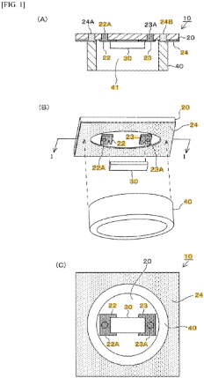
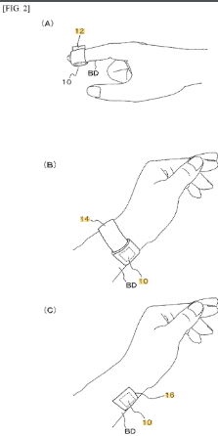
First, an example of a vibration waveform sensor according to the present invention is explained by referring to FIGS. 1 to 3. In FIG. 1, how the present invention is used as a pulse wave sensor is shown. FIG. 1 (A) shows a cross-sectional view, FIG. 1 (B) shows an exploded view, and FIG. 1 (C) shows a view from the bottom face, of a sensor module 10. In these drawings, the sensor module 10 is structured in such a way that a piezoelectric element 30 is placed on the principal face of a board 20, and the piezoelectric element 30 is surrounded by a vibration ring 40. The piezoelectric element 30 is rectangular, as shown in FIG. 1 (C), and has a longitudinal direction.
As shown in FIG. 2, the sensor module 10 described above is installed in an appropriate position on a person's arm, neck, etc., using a medical fixing tape, etc., in such a way that the vibration ring 40 contacts the person's skin BD. FIG. 2 (A) shows the module installed on a fingertip with a medical fixing tape 12, FIG. 2 (B) shows the module wrapped around an arm using a surface fastener 14, and FIG. 2 (C) shows the module attached to an arm with a medical fixing tape 16.
Next, the waveform analysis device 100 is constituted by a PC (personal computer), smartphone, tablet PC, etc., and as shown in FIG. 4 (C), it has a CPU 102, a data memory 110, a program memory 120, and a display 104. Programs stored in the program memory 120 are run by the CPU 102. As the programs are run, the data stored in the data memory 110 are referenced. The calculation results are stored in the data memory 110 and also shown on the display 104. These basic operations are general in nature and all of them are known.
At the waveform analysis device 100, the input data is stored as waveform data 112 in the data memory 110. As the noise elimination program 122 is run by the CPU 102, a disturbance exceeding a preset threshold may be found in the waveform data 112, in which case the waveform peak will be held to eliminate the noise. As the waveform analysis program 124 is run by the CPU 102, Pa through Pe waves are detected from the waveforms and also the aforementioned Pb/Pa, Pc/Pa, Pd/Pa, Pe/Pa, (Pb−Pc−Pd−Pe)/Pa, etc., are calculated, and the calculation results are stored in the data memory 110 as calculation data 114 and also displayed on the display 104. In addition, the arrhythmia detection program 126 is run by the CPU 102 to detect arrhythmia. Furthermore, if any of the calculation results exceeds a threshold or arrhythmia is detected, a corresponding alarm is output by the alert program 128 in the form of light or sound.
CLAIMS:
1. A vibration waveform sensor, comprising:
a circuit board having a principal face and a reverse side face opposite to the principal face;
a piezoelectric element provided on the circuit board, that continuously receives vibrations of the circuit board and obtains vibration waveforms, said piezoelectric element having electric connection on the reverse side face of the circuit board for connecting to an amplifier; and
a vibration-conveying body that is a protrusion provided on and protruding from the principal face of the circuit board in a vicinity of the piezoelectric element, and that is configured to contact a target and transmits vibrations of the target to the circuit board,
wherein the vibration-conveying body is electrically conductive and electrically connected to a ground conductor which is provided on the principal face of the circuit board.
2. The vibration waveform sensor according to claim 1, wherein a signal amplifier for amplifying signals of the vibration waveforms obtained from the piezoelectric element, is provided on the circuit board.
Analyst Comments:
The reference does not disclose a system for detecting human emotions/reactions based on human body resonance (or vibrations).
The reference does not disclose that the vibrational impulse detection module is configured for battery less operation.
The reference does not disclose that the vibrational impulse detection module is configured to convert vibrational energy, impulses or body resonance into usable electric and kinetic energy to charge the device.
The reference does not disclose that the vibrational impulse detection module comprises accelerometers, gyroscopes, and EM sensors for multi-axis resonance capture.
The reference does not disclose that the system comprises a centre-of-mass (COM) and centre-of-gravity (COG) calculation engine configured to compute micro-shifts in skeletal alignment of the human body.
The reference does not disclose that the engine use vibrational signal captured by the piezoelectric tracker to compute the COM and COG shift of the human body.
The reference does not disclose that the engine employs machine learning algorithms configured to map vibrational amplitude and frequency to COM and COG vectors and compute the shift.
The reference does not disclose that the computed shift in the human body is used to interpret an emotional and kinetic intention/state of the human from the computed COM and COG shift in the human body.
The reference does not disclose that the device is configured to transmit electrical signal converted from vibrations to the human body based on the shift in COM and COG to train the muscles and nullify the COM and COG Shift automatically in real time.
The reference does not disclose that the electrical signal is transmitted up to a certain threshold (less than 5% of average muscle torque) to prevent user discomfort.
The reference does not disclose that the engine implements a resonance deviation index (RDI) algorithm to determine deviation thresholds for emotional or physical instability.
The reference does not disclose that the engine is configured to correlate the vibration frequency with corresponding emotional states based on a predefined relationship, wherein the total resonance response H(t) is equal to the product of an impulse coupling coefficient alpha (α) and an input impulse I(t), added to the product of a resonance amplitude coefficient beta (β) and the sine of omega (ω) t plus phi (ϕ), wherein omega (ω) represents angular frequency and phi (ϕ) represents phase shift.
The reference does not disclose that if the frequency is greater than a predetermined threshold (7.5) and amplitude is greater than a predetermined threshold (0.8), the GUI displays excited state of the human, if the frequency is less than a predetermined threshold (4), the GUI displays calm state of the human and if the frequency lies between the thresholds (4–7.5), the GUI displays an uncertain state of the human.
The reference does not disclose that the results are displayed in the form of glyphs (symbols) (for example: ◉ for centred COM, ꙮ for sensory overactivity, 𒀯 for collective breath state).
The reference does not disclose that the system comprises a feedback module.
The reference does not disclose that the feedback is generated based on the results/glyphs displayed on the screen (for example: feedback for sensory overactivity is; reduce sensory input etc.).
The reference does not disclose that the feedback module operates in closed loop, adjusting its output based on continuously updated resonance data in real time.
The reference does not disclose that the alert is generated if there is any change in the results/glyphs displayed in real time.
The reference does not disclose that the alert generation module is configured to forecast potential emotional-state shifts before deviation thresholds are exceeded.

Reference 3
Publication No: CN109528217A (Hyperlink)
Title: Emotion detection and warning method based on physiological vibration analysis
Applicant: Beijing Rostec Technology CO. LTD
Priority Date: 2018-10-16
ABSTRACT:
The present invention discloses an emotion detection and early warning method based on physiological vibration analysis, which can realize non-contact detection and early warning of a person's emotional state by analyzing the physiological vibration signals of the human body. The method specifically includes six functional modules: video data stream input, physiological vibration signal extraction, physiological vibration emotion calculation, computational model training and optimization, emotional state determination, and abnormal emotion early warning push.
TECHNICAL FIELD:
The present invention relates to the technical field of emotion recognition, and in particular to an emotion detection and early warning method based on physiological vibration analysis.
SUMMARY:
In order to overcome the above-mentioned deficiencies in the prior art, the present invention provides an emotion detection and early warning method based on physiological vibration analysis.
This method can realize the real collection of emotional data without requiring the individual being tested to wear any signal collection equipment. Therefore, it can realize non-contact recognition of the emotional state of the individual being tested and can be applied to a variety of practical application scenarios.
DETAILED DESCRIPTION:
Among them, the physiological vibration signal extraction module is responsible for analyzing the front-end video data, locating and extracting features of individual people, detecting and analyzing the facial and neck muscle vibrations of each tested individual frame by frame, extracting relevant physiological parameters such as vibration amplitude and frequency, and outputting them to the physiological vibration emotion calculation module.
The physiological vibration emotion calculation module is responsible for analyzing and calculating the recorded muscle vibration amplitude and frequency and other related physiological parameters, so as to detect the emotional state of the individual being tested and obtain the emotional state value of the individual being tested.
The emotional state determination module is responsible for determining the emotional state value of the measured individual. If the value is higher than a preset threshold, the abnormal emotional warning push module is triggered.
According to the principle of human physiological vibration emotion detection function, human physiological vibration image data can be captured through a standardized video imaging system.
Each pixel in the image reflects the frequency or amplitude of that point. The combination of frequency and amplitude parameters reflects emotions and human physiological characteristics. By calculating the differences in mathematical parameters and frequency distribution histogram conditions, subtle emotional changes can be distinguished.
The core of this technology is to use video image analysis algorithms to obtain visual results of multiple variables to evaluate people's psychological and emotional states.
Using video image analysis technology, we analyze and match people's physiological parameters based on the principle of human physiological vibration emotion detection. Through the changes in pixels between each frame of dozens of frames over a few seconds, we use mathematical algorithms to analyze the physiological signal parameters corresponding to the person's three-dimensional spatial state. Through specific algorithms, we confirm the person's emotional state in different time and space, and realize non-contact emotion recognition based on video analysis.
Since the amplitude and frequency of human head vibrations vary at any point in time and space, the amplitude of each pixel and the ratio of image motion per frame rate in general motion reflect the relative motion of the stored image. This information can be reduced to millimeters or microns in a color-coded manner.
CLAIMS:
1. An emotion detection and warning method based on physiological vibration analysis can achieve non-contact detection and warning of human emotional state by analyzing the physiological vibration signals of the human body. It specifically includes five functional modules: video data stream input, physiological vibration signal extraction, physiological vibration emotion calculation, computational model training and optimization, emotion state determination, and abnormal emotion warning push.
Analyst Comments:
The reference does not disclose that the impulses are tracked using a wearable device comprising a piezoelectric tracker/sensor.
The reference does not disclose that the vibrational impulse detection module is configured for battery less operation.
The reference does not disclose that the vibrational impulse detection module is configured to convert vibrational energy, impulses or body resonance into usable electric and kinetic energy to charge the device.
The reference does not disclose that the vibrational impulse detection module comprises accelerometers, gyroscopes, and EM sensors for multi-axis resonance capture.
The reference does not disclose that the system comprises a centre-of-mass (COM) and centre-of-gravity (COG) calculation engine configured to compute micro-shifts in skeletal alignment of the human body.
The reference does not disclose that the engine use vibrational signal captured by the piezoelectric tracker to compute the COM and COG shift of the human body.
The reference does not disclose that the engine employs machine learning algorithms configured to map vibrational amplitude and frequency to COM and COG vectors and compute the shift.
The reference does not disclose that the computed shift in the human body is used to interpret an emotional and kinetic intention/state of the human.
The reference does not disclose that the device is configured to transmit electrical signal converted from vibrations to the human body based on the shift in COM and COG to train the muscles and nullify the COM and COG Shift automatically in real time.
The reference does not disclose that the electrical signal is transmitted up to a certain threshold (less than 5% of average muscle torque) to prevent user discomfort.
The reference does not disclose that the engine implements a resonance deviation index (RDI) algorithm to determine deviation thresholds for emotional or physical instability.
The reference does not disclose that the engine is configured to correlate the vibration frequency with corresponding emotional states based on a predefined relationship, wherein the total resonance response H(t) is equal to the product of an impulse coupling coefficient alpha (α) and an input impulse I(t), added to the product of a resonance amplitude coefficient beta (β) and the sine of omega (ω) t plus phi (ϕ), wherein omega (ω) represents angular frequency and phi (ϕ) represents phase shift.
The reference does not disclose that the system comprises a graphical user interface (GUI) configured to display the results/feedback based on the tracking.
The reference does not disclose that if the frequency is greater than a predetermined threshold (7.5) and amplitude is greater than a predetermined threshold (0.8), the GUI displays excited state of the human, if the frequency is less than a predetermined threshold (4), the GUI displays calm state of the human and if the frequency lies between the thresholds (4–7.5), the GUI displays an uncertain state of the human.
The reference does not disclose that the results are displayed in the form of glyphs (symbols) (for example: ◉ for centred COM, ꙮ for sensory overactivity, 𒀯 for collective breath state).
The reference does not disclose that the system comprises a feedback module.
The reference does not disclose that the feedback is generated based on the results/glyphs displayed on the screen (for example: feedback for sensory overactivity is; reduce sensory input etc.).
The reference does not disclose that the feedback module operates in closed loop, adjusting its output based on continuously updated resonance data in real time.
The reference does not disclose that the alert is generated if there is any change in the results/glyphs displayed in real time.
The reference does not disclose that the alert generation module is configured to forecast potential emotional-state shifts before deviation thresholds are exceeded.

Reference 4 – Non-Patent Literature (NPL-1)
Title: Personalized Emotion Detection from Floor Vibrations Induced by Footsteps (Hyperlink)
Source: Arxiv
ABSTRACT:
Emotion recognition is critical for various applications, including the early detection of mental health disorders and emotion-based smart home systems. Previous studies utilized various sensing methods for emotion recognition, such as wearable sensors, cameras, and microphones. However, these methods have limitations in long-term domestic use because of the inherent limitations, including intrusiveness and privacy concerns. To overcome these limitations, this paper introduces a non-intrusive and privacy-friendly personalized emotion recognition system, EmotionVibe, which leverages footstep-induced floor vibrations for emotion recognition. The main idea of EmotionVibe is that individuals’ emotional states influence their gait patterns, subsequently affecting the floor vibrations induced by their footsteps. However, there are two main research challenges: 1) the complex and indirect relationship between human emotions and footstep-induced floor vibrations and 2) the large between-person variations within the relationship between emotions and gait patterns. To address these challenges, we first empirically characterize this complex relationship and develop an emotion-sensitive feature set including gait-related and vibration-related features from footstep-induced floor vibrations. Furthermore, we personalize the emotion recognition system for each user by calculating gait similarities between the target person (i.e., the person whose emotions we aim to recognize) and those in the training dataset and assigning greater weights to training people with similar gait patterns in the loss function. We evaluated our system in a real-world walking experiment with 20 participants, summing up to 37,001 footstep samples. EmotionVibe achieved the mean absolute error (MAE) of 1.11 and 1.07 for valence (unpleasant to pleasant) and arousal (calm to excited) score estimations, respectively, reflecting 19.0% and 25.7% error reduction compared to the baseline method.
RELATED WORKS:
Body behavior is another important indicator of human emotions. Previous research has utilized cameras, motion capture systems, smartwatches, smartphones, and force platforms to analyze human gait behavior, posture, and other body movements to infer the user’s emotional state. Camera and motion-capturing-based methods are contactless methods that capture a broad range of movements and can extract skeletal and joint locations for emotion recognition. Compared to facial expression recognition-based emotion recognition, these methods are effective when the subject is away from the camera or when facial features are obscured. However, they can still cause privacy concerns for in-home scenarios and are limited by visual obstacles. The wearable or mobile device-based methods, use body-attached or embedded sensors in mobile devices to record movements directly for emotion recognition. These devices, equipped with accelerometers and gyroscopes, realize emotion recognition by analyzing the occupants’ movement information. Although more convenient than wired sensors, they still require users to carry or wear the device which limits their everyday applicability. The force-based methods, involve measuring ground reaction forces using force platforms during walking to recognize emotions. However, the limited coverage of force platforms necessitates dense deployment, restricting their suitability for in-home use.
VIBRATION ANALYSIS AND MODELLING:
Previous studies proposed various feature extraction methods for vibration and audio signal processing to capture signal features, which can be categorized into classical and deep learning-based methods. Classical methods extract features based on interpretable physical principles of signal processing research, including time-domain features (mean, kurtosis, zero-crossing rate, envelope analysis), frequency-domain features (Fourier transform, power spectral density), and time-frequency-domain spectral features (mel-frequency cepstral coefficients, short-time Fourier transform, constant Q transform, and wavelet transform). These features can handle transient and non-stationary signals and are used for pattern analysis in speech recognition , speaker dentification, structural health monitoring, and human-building interaction studies. These classical features are interpretable and computationally efficient but often rely on domain expertise to design effective feature sets. On the other hand, deep learning-based methods, including convolutional neural networks and autoencoders, can automatically extract complex hierarchical features from raw signals or spectrograms, enabling robust performance in tasks such as fault detection and sound classification. However, they are computationally intensive and require a large number of high-quality datasets for learning the implicit relationships. EmotionVibe is a combination of these two approaches. We first analyze the complex relationship between emotion and footstep-induced floor vibrations and develop an emotion-sensitive feature set based on this relationship, including gait-related and vibration-related features. Then, we model these features using a deep learning framework to learn implicit relationships that cannot be directly given by classical features.
INTRODUCTION:
Emotion recognition is crucial for various applications, such as mental health monitoring and emotion-based smart home devices [1, 2, 3]. According to the National Institute of Mental Health (NIMH), 23.1% U.S. adults, approximately 59.3 million individuals live with a mental illness in 2022 [4]. On average, individuals with anxiety or depression have a lifespan of 7.9 years shorter than those without these conditions [5]. Since mental health disorders are often characterized by increased emotional instability and fluctuations [6], monitoring changes in individuals’ emotions can facilitate the early detection and intervention of severe mental illnesses [7]. In addition, integrating emotion recognition systems into smart home devices enables adaptive recommendation systems that enhance user interaction. For example, emotional data can inform music recommendations, adjust lighting and temperature for comfort or relaxation [8, 9], and provide personalized content suggestions for smart TVs and video games [10, 11].
In previous work, various sensing methods have been used for emotion recognition, including wearable sensors [12, 13], cameras [14, 15], microphones [16, 17], and multi-modal sensing methods [18, 19]. However, these methods are limited in long-term domestic usage because of intrusiveness or privacy concerns. Wearable sensors are intrusive and may cause discomfort. Cameras and microphones, which rely on capturing facial expressions, body postures, or speaking voices, often raise privacy concerns. Multi-modal sensing requires increased hardware deployment and data processing complexity. These limitations restrict the widespread use of emotion recognition systems for indoor applications.
This paper introduces EmotionVibe, a novel personalized emotion recognition system that infers human emotions through footstep-induced floor vibrations (see Fig. 1). The main intuition of EmotionVibe is that people’s emotion influences their gait patterns, which in turn affect the floor vibrations induced by their footsteps. To this end, by analyzing footstep-induced floor vibration patterns captured by the vibration sensors attached to the floor, the emotional state of the pedestrian can be inferred. We showed a proof of concept for this intuition through preliminary small-scale laboratory experiments in our previous work [20]. Compared to other sensing methods, EmotionVibe offers a non-intrusive and privacy-friendly personalized emotion recognition method.
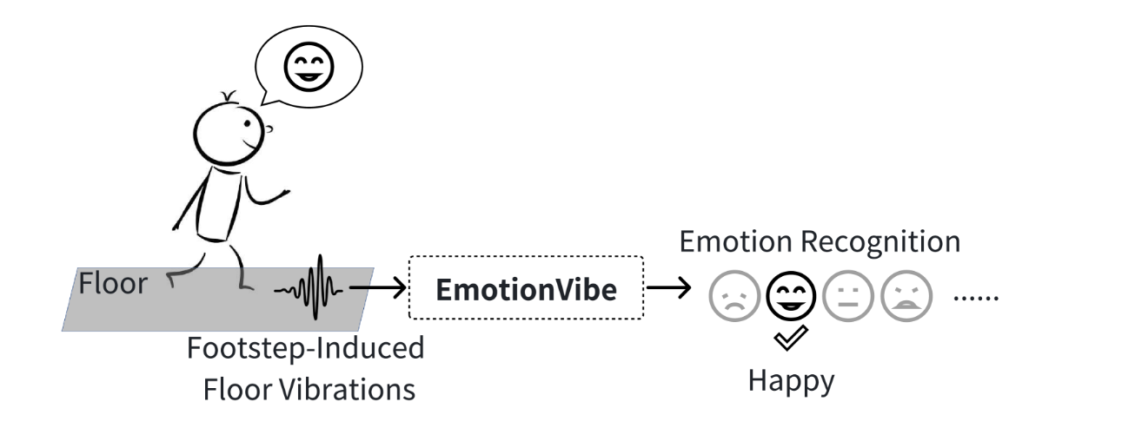
To capture the complex relationship between human emotions and footstep-induced floor vibrations, we develop emotion-sensitive features from two aspects: gait-related and vibration-related features. The selection of these features is inspired by an analysis of how emotions influence gait pattern parameters including kinematic, kinetic, and spatiotemporal parameters, and how these gait patterns impact the characteristics of footstep-induced floor vibrations.
Characterizing the Relationship Between Emotions and Footstep-Induced Floor Vibrations:
EmotionVibe is based on the insight that human emotions affect their gait patterns, subsequently influencing the footstep-induced floor vibration patterns (see Fig. 2). To this end, we can infer people’s emotional states by analyzing the footstep-induced floor vibration patterns captured by the vibration sensors attached to the floor. In this section, we analyze and characterize the relationship between human emotions and footstep-induced floor vibrations through both analytical and empirical studies.
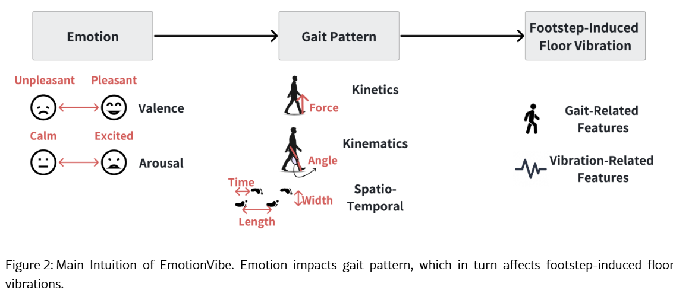
EmotionVibe: Emotion Recognition System Using Footstep-Induced Floor Vibrations:
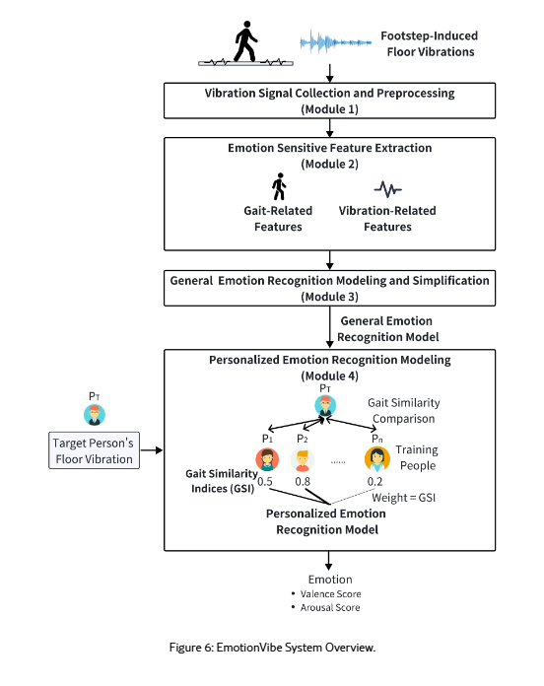
The EmotionVibe system collects and analyzes floor vibration signals induced by footsteps to recognize the pedestrian’s emotions with four modules: 1) Vibration signal collection and preprocessing, 2) Emotion-sensitive feature extraction, 3) General emotion recognition modeling and simplification, and 4) Personalized emotion recognition modeling (see Fig. 6). After collecting and preprocessing footstep-induced floor vibration data (Module 1), we capture the complex relationship between human emotion and floor vibrations by developing emotion-sensitive feature sets to address the first challenge (Module 2). These features, inspired by the relationship between human emotions and floor vibrations discussed in Section III, include gait-related and vibration-related features. Next, a general emotion recognition model is developed for preliminary emotion recognition and data-driven emotion information extraction from features (Module 3). This model is subsequently personalized to the target person (i.e., the person whose emotions we aim to recognize) to tackle the second challenge (Module 4). The personalization is achieved by first comparing the gait similarities between the vibration data from the target person and the training people. These gait similarities are then employed as weighting factors in the loss function during model fine-tuning, resulting in a personalized emotion recognition model. Finally, EmotionVibe outputs the target person’s emotion estimation results, represented by valence and arousal scores.
Module 1: Vibration Signal Collection and Preprocessing:
The vibration signal collection and preprocessing module includes three steps: 1) footstep-induced floor vibration signal collection, 2) single footstep signal segmentation, and 3) signal clipping calibration. First, we collect vertical floor vibrations using geophone sensors. Geophones are selected for their low cost and high sensitivity to vertical floor velocity in the low-frequency range (0–200 Hz), which aligns with the range of footstep-induced floor vibrations [27]. The collected vibrations are then sent to an amplifier board to enhance their signal-to-noise ratio. Next, we segment the vibration signals representing each footstep (defined as a single footstep signal) for gait analysis by identifying the prominent peak in the wavelet transform coefficients within the frequency band of dominant structural natural frequencies (selected based on the floor type and specified in Section V-C). This peak corresponds to the impulse force induced by a single footstep. The signal window of the average footstep duration (chosen as 0.35 s based on our observation) is then extracted around this peak to segment the single footstep signal. Finally, to enhance signal quality, we identify the clipped signal sections and then use polynomial interpolation to reconstruct the clipped signal section using the neighboring data points of the clipped sections. The clipped sections are detected when the signal reaches the upper or lower limit that the sensor can measure and remains at the limit for at least 3 samples, representing the section where the signal exceeds the range of the vibration sensor. Assuming the signal remains continuous, the signal is reconstructed by fitting a polynomial function with the neighboring points of the clipped section and then using this function to interpolate the data within the clipped sections. After interpolation, we obtain a continuous signal representation for the clipped sections with enhanced signal quality.
Module 2: Emotion-Sensitive Feature Extraction:
To capture the complex relationship between human emotions and floor vibrations, we develop gait-related and vibration-related features from the preprocessed single footstep signals. Gait-related features capture gait parameters influenced by emotions during the gait cycle, reflecting footstep characteristics. Vibration-based features, on the other hand, capture the detailed characteristics of vibration signals induced by footsteps. The selection of these features is inspired by our investigation of the relationship between human emotions and footstep-induced floor vibrations (see Section III).
Gait-Related Features:
Gait-related features are based on gait parameters in the gait cycle and provide basic information about footstep patterns influenced by emotions. Gait-related features include a variety of gait parameters: step frequency, double support time, peak height ratio of heel-strike and toe-off, full width at half maximum (FWHM) of heel-strike and toe-off, and energy contours (including the raw, smoothed, and logarithm energy contour).
The gait-related features are chosen based on the influence of human emotions on gait patterns and the corresponding affected gait parameters (see Section III). For example, step frequency usually increases under emotions like anxiety or happiness, while a slower step frequency might reflect sadness or fatigue [22, 21]. Double support time can help identify cautious and confident walking [109]. The peak-to-height ratio between heel-strike and toe-off indicates the angle between the foot and floor during the stance phase and is related to the degree to which a person’s center of gravity is tilted back (larger during relax states when leaning backward) [110]. In addition, the FWHM indicates the duration of the heel-strike and toe-off processes, and the energy contours indicate the footstep strength and temporal changes of the footstep force. For energy features, we collectively include raw, smoothed, and logarithmic energy contours in our feature set. Based on empirical data analysis, using all three types of energy contours is superior to using any single energy contour. The likely reason for this is that raw energy reveals fine details, smoothed energy reveals overall trends, and logarithmic energy highlights changes associated with perception. To this end, combining these three types of energy features makes the analysis more robust and not limited by any single representation.
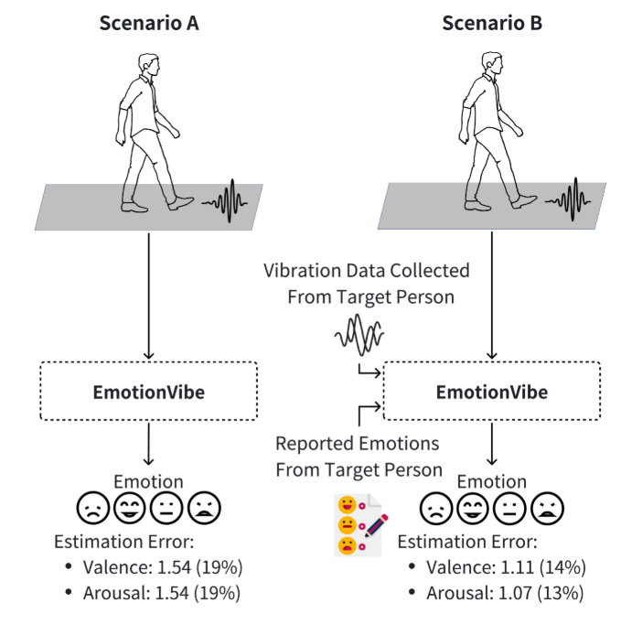
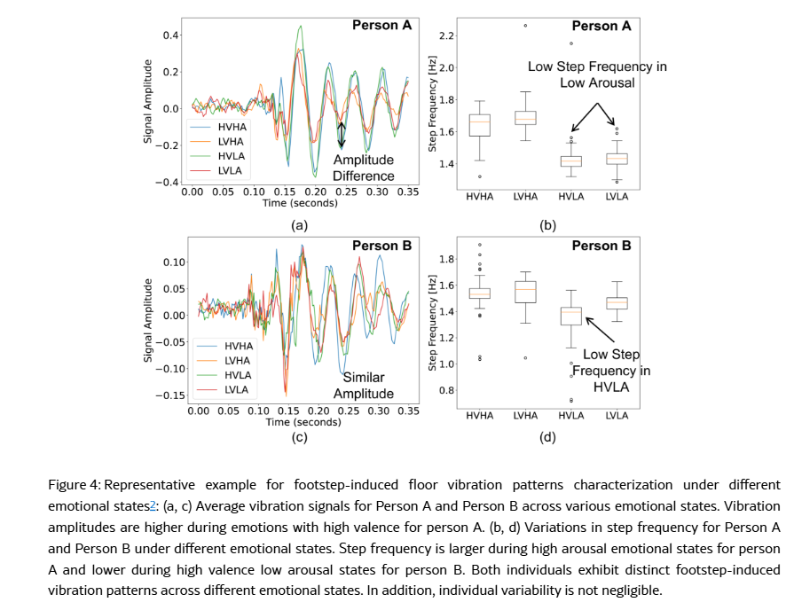
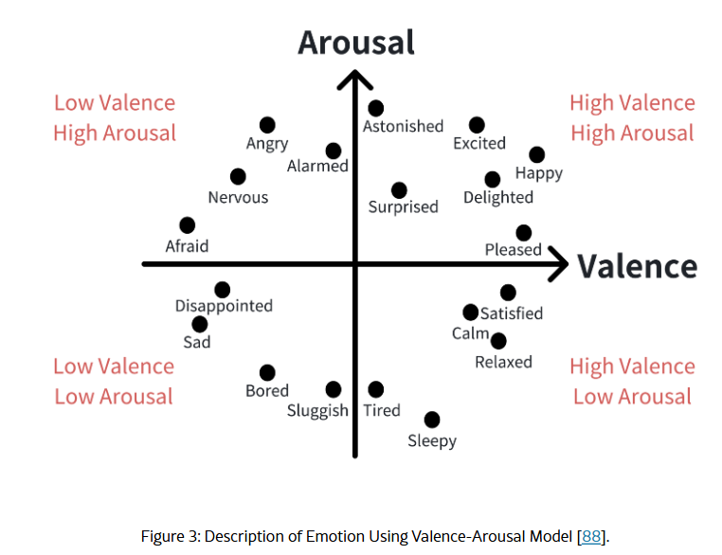
Analyst Comments:
The reference does not disclose that the impulses are tracked using a wearable device comprising a piezoelectric tracker/sensor.
The reference does not disclose that the vibrational impulse detection module is configured for battery less operation.
The reference does not disclose that the vibrational impulse detection module is configured to convert vibrational energy, impulses or body resonance into usable electric and kinetic energy to charge the device.The reference does not disclose that the device is configured to transmit electrical signal converted from vibrations to the human body based on the shift in COM and COG to train the muscles and nullify the COM and COG Shift automatically in real time.
The reference does not disclose that the electrical signal is transmitted up to a certain threshold (less than 5% of average muscle torque) to prevent user discomfort.
The reference does not disclose that the engine implements a resonance deviation index (RDI) algorithm to determine deviation thresholds for emotional or physical instability.
The reference does not disclose that the engine is configured to correlate the vibration frequency with corresponding emotional states based on a predefined relationship, wherein the total resonance response H(t) is equal to the product of an impulse coupling coefficient alpha (α) and an input impulse I(t), added to the product of a resonance amplitude coefficient beta (β) and the sine of omega (ω) t plus phi (ϕ), wherein omega (ω) represents angular frequency and phi (ϕ) represents phase shift.
The reference does not specifically disclose that the system comprises a graphical user interface (GUI) configured to display the results/feedback based on the tracking. However, the reference discloses “the system provides the result of emotional state of the user”.
The reference does not disclose that the feedback is generated based on the results/glyphs displayed on the screen (for example: feedback for sensory overactivity is; reduce sensory input etc.).
The reference does not disclose that the feedback module operates in closed loop, adjusting its output based on continuously updated resonance data in real time.
The reference does not disclose that the system comprises an alert generation module.
The reference does not disclose that the alert is generated if there is any change in the results/glyphs displayed in real time.
The reference does not disclose that the alert generation module is configured to forecast potential emotional-state shifts before deviation thresholds are exceeded.

Reference 5 – Non-Patent Literature (NPL-2)
Title: Wearable Biomechanical Energy Harvesting Technologies (Hyperlink)
Source: MDPI
ABSTRACT:
Energy harvesting has been attracting attention as a technology that is capable of replacing or supplementing a battery with the development of various mobile electronics. In environments where stable electrical supply is not possible, energy harvesting technology can guarantee an increased leisure and safety for human beings. Harvesting with several watts of power is essential for directly driving or efficiently charging mobile electronic devices such as laptops or cell phones. In this study, we reviewed energy harvesting technologies that harvest biomechanical energy from human motion such as foot strike, joint motion, and upper limb motion. They are classified based on the typical principle of kinetic energy harvesting: piezoelectric, triboelectric, and electromagnetic energy harvesting. We focused on the wearing position of high-power wearable biomechanical energy harvesters (WBEHs) generating watt-level power. In addition, the features and future trends of the watt-level WBEHs are discussed.
INTRODUCTION:
The human body generates kinetic energy in various forms by using muscles, such as foot strike; motions of joints such as ankle, knee, hip, arm, and elbow; and center-of-gravity (COG) motion of the upper body [7,8,9]. Among the human body motions, lower limb motions, such as ankle, knee, and hip motions induce high biomechanical energy because these joints generate a larger torque than other human joints, as listed in Table 1. In particular, during walking or gait motion, the abovementioned motions are periodically repeated, indicating that energy can be harvested continuously. The frequency of gait motion is normally about 0.5–3 Hz which corresponds to a walking speed of 1.3–7.8 km/h. Therefore, many studies have focused on harvesting biomechanical energy generated during gait motion.
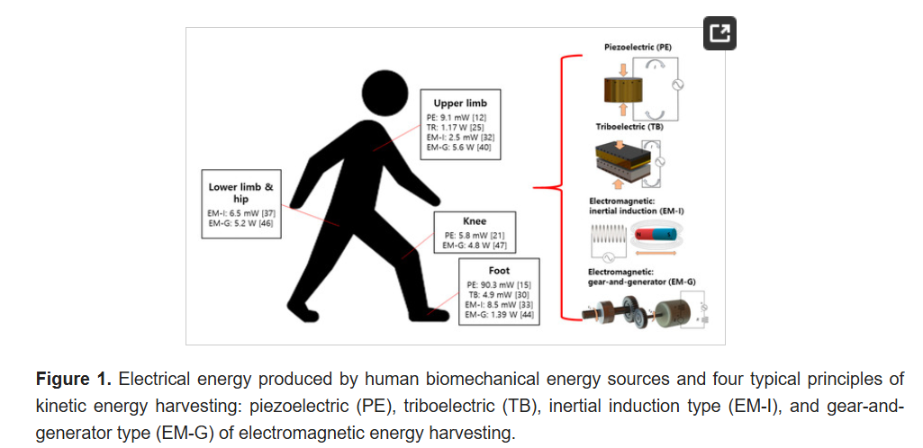
A piezoelectric energy harvester (PEH) uses the piezoelectric effect to generate electricity when force is applied. A polyvinylidene fluoride (PVDF) film [12,14,16,17,18], lead zirconate titanate (PZT) stack [13], and PZT bimorph [15,16,19,20,21] have been used as piezoelectric materials for a wearable PEH. Table 2 lists recently reported wearable PEHs. Although PEHs have a low-power output, of mW-level, and poor efficiency in low-frequency regime [18], they have a small footprint in terms of volume and generates electricity even when the displacement is small. PZT is fragile and weak when subjected to shear force. However, flexible and stretchable piezoelectric devices have recently been developed and applied for harvesting energy from natural motions of internal organs [10]. In order to maximize the piezoelectric effect, it is necessary to install the PEH in a part of the human body that is subjected to a large compressive or tensile force. In many studies, PEHs were implemented in the shoe soles at the point where the foot applies the highest pressure in the human body [14,15,16,17,18,19]. In some cases, repetitively applied tensile force is converted into electrical energy by the COG motion of an inertial load [12,13]. Even in the absence of the direct compression/tension by the human body, vibrational energy can be converted into electrical energy by PEHs. When the piezoelectric strip is plucked mechanically or magnetically by knee motion, it vibrates and generates electric power [20,21].
Analyst Comments:
The reference does not disclose that the vibrational impulse detection module comprises accelerometers, gyroscopes, and EM sensors for multi-axis resonance capture.
The reference does not disclose that the engine is configured to compute the shift in COM and COG of the human body via the captured vibrational signals.
The reference does not disclose that the engine employs machine learning algorithms configured to map vibrational amplitude and frequency to COM and COG vectors and compute the shift.
The reference does not disclose that the engine is configured to interpret an emotional and kinetic intention/state of the human from the computed COM and COG shift in the human body.
The reference does not disclose that the device is configured to transmit electrical signal converted from vibrations to the human body based on the shift in COM and COG to train the muscles and nullify the COM and COG Shift automatically in real time.
The reference does not disclose that the electrical signal is transmitted up to a certain threshold (less than 5% of average muscle torque) to prevent user discomfort.
The reference does not disclose that the engine implements a resonance deviation index (RDI) algorithm to determine deviation thresholds for emotional or physical instability.
The reference does not disclose that the engine is configured to correlate the vibration frequency with corresponding emotional states based on a predefined relationship, wherein the total resonance response H(t) is equal to the product of an impulse coupling coefficient alpha (α) and an input impulse I(t), added to the product of a resonance amplitude coefficient beta (β) and the sine of omega (ω) t plus phi (ϕ), wherein omega (ω) represents angular frequency and phi (ϕ) represents phase shift.
The reference does not disclose that the system comprises a graphical user interface (GUI) configured to display the results/feedback based on the tracking.
The reference does not disclose that the system is configured to display an excited state of a human when the frequency is greater than a predetermined threshold (7.5) and amplitude is greater than a predetermined threshold (0.8); if the frequency is less than a predetermined threshold (4), the GUI displays calm state of the human and if the frequency lies between the thresholds (4–7.5), the GUI displays an uncertain state of the human.
The reference does not disclose that the results are displayed in the form of glyphs/symbols (for example: ◉ for centred COM, ꙮ for sensory overactivity, 𒀯 for collective breath state).
The reference does not disclose that the system comprises a feedback module.
The reference does not disclose that the feedback is generated based on the results/glyphs displayed on the screen (for example: feedback for sensory overactivity is; reduce sensory input etc.).
The reference does not disclose that the feedback module operates in closed loop, adjusting its output based on continuously updated resonance data in real time.
The reference does not disclose that the system comprises an alert generation module.
The reference does not disclose that the alert is generated if there is any change in the results/glyphs displayed in real time.
The reference does not disclose that the alert generation module is configured to forecast potential emotional-state shifts before deviation thresholds are exceeded.

Disclaimer
The objective of this report is to position the invention within the relevant technical field as reflected in patent and non-patent literature. This search report was created based on information that was provided to IPflair Consulting Private Limited. (hereinafter referred to as IPflair). While every effort has been made to ensure the accuracy and completeness of this search report, because of the subjective natures of such searches and possible incomplete databases, we cannot warrant that our search reports are 100% complete or error-free. Accordingly, we disclaim all warranties of correctness or completeness of the data or fitness for a particular purpose.
The work product is limited by time limit set by the customer and also by several other factors including the legibility of the data. IPflair is not liable for any action taken by the reviewer pursuant to this report or on the basis of this report; in any case, IPflair is not liable beyond what IPflair has charged for preparing this report. In case the reader/reviewer does not accept a part or full of the conditions and limitations mentioned in this section, the said reader/reviewer should inform IPflair immediately and request for necessary actions to be taken accordingly.

